Fairy Tales in Visual Media
Comparing Rackham's illustrations of Cinderella (from the 1800s) and Disney's.

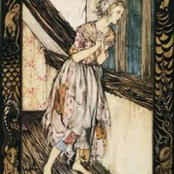
By: Myanna Allen
Instructor: Abigail Heiniger

Illustration’s From Brothers Grimm’s tales
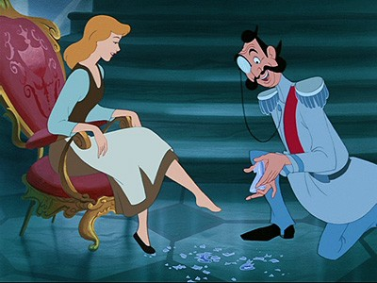

Disney’s illustration
One out of many popular known fairy tales is indeed “The Cinderella Story”. There are several versions of this specific fairy tale ranging from gruesome to kid friendly versions of this story. The illustration of the different versions are presented in a different matter while the whole concept as well as events in the fairy tale continue to stay the same. The two illustrations compared in this essay will be Rackham’s illustration from the 1800’s and Disney’s illustrations of this fairy tale. The Brothers Grimm version of Cinderella is more gruesome and does not sugar coat anything in this story while on the other hand Disney’s version hides most of the evil in this tale as well as portraying the way Cinderella was presented as a maid. Looking at the both illustrations one sugar coats, and portrays Cinderella’s story in order to stay suitable for its viewers as the other stay as blunt as possible with her image and the situation with her evil stepmother and stepsisters.
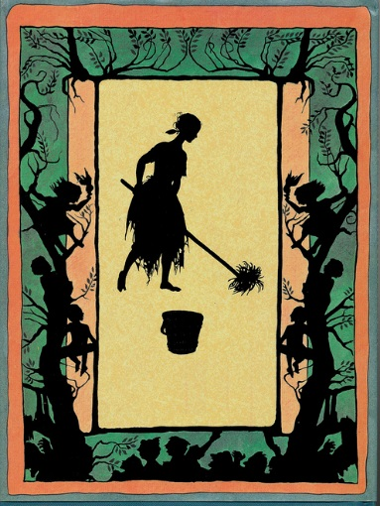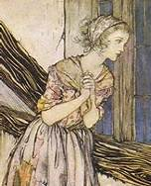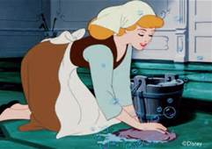

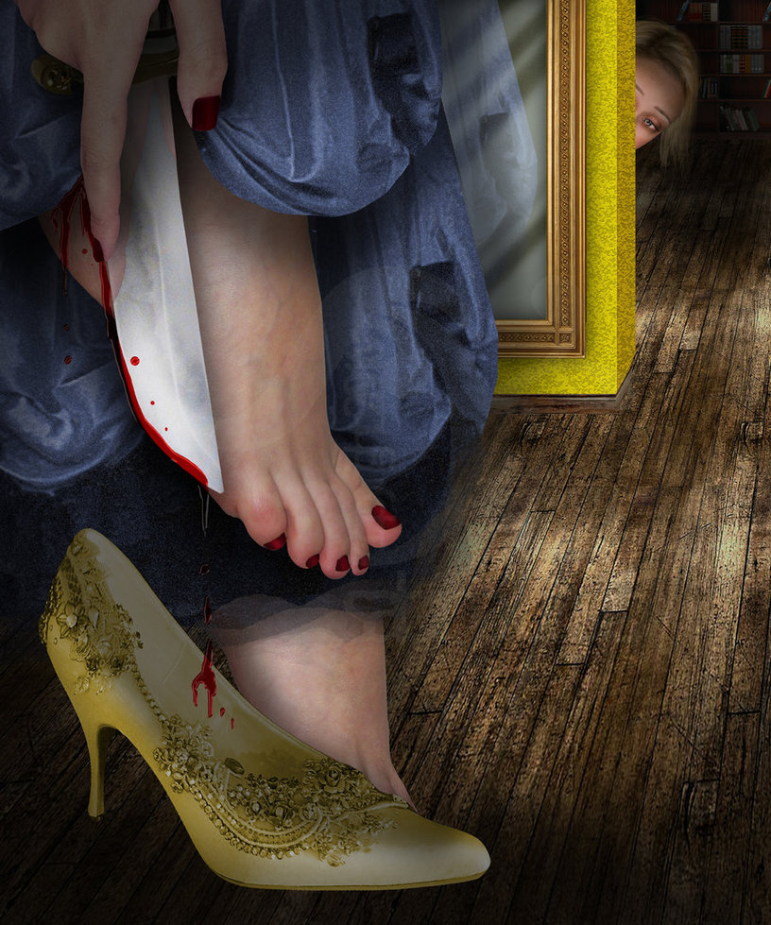

The Grimm Brother’s version of “The Cinderella Story” follows in the category of a more gruesome version and it is all presented within its illustration. I argue on the topic of this being how each version should be expressed without sugar coating the events that the character had to go through. Cinderella’s life was far from peachy, and she was dressed and treated as if she was the maid in her own home. The illustrations in this version shows you what a maid looked like and how dirty her clothes were because she was not treated fairly as her step sister’s. I believe the message sent through their illustrations were sent out for its audience that were once brainwashed by Disney’s illustrated pictures to realized maids were not presented that way in the 1800’s. Though Disney wanted to fantasize up the perfect clean image of Cinderella for the audience it was going for which was younger children I believe it brainwashed us into not seeing the struggles of this character. The Grimm Brother’s version of this fairy tale expressed a lot of hidden in between lines and unspoken of pieces for our Childhood Disney version. The picture above is an example of the read in between the lines that Disney did not express nor provide in its tale. The first time reading this tale I could understand as well as see how evil and desperate the evil step mother was. In order for one of Cinderella’s stepsisters to fit the glass slipper she was told by her mother that she must cut her pinky toe off and so she did. The other stepsister was told she had to chop her heel off in order to fit the slipper and she as well failed. Again both stories may have the same concept but the illustrations of the tale explain which version portrayed the true story of Cinderella as well as sugar coated her image.

After reading the Grimm Brothers version and reviewing each of the illustrations I believe the image of Cinderella was portrayed and looked over. The image of a maid in Disney’s version was a clean women that was just treated as if she was below everyone else. In Disney’s illustrations every picture is colorful and glossy and defeats the fact Cinderella was not in a perfect situation at first, and there was a lot of despair and sadness and the illustration could not make that connection with its readers therefore brain washing each and every child mostly little girls in to wanting to have a life just as similar to Cinderella. If every child read the gruesome version and saw exactly how Cinderella should have been portrayed then it would flip the emotions of every little girl out there because her life was not Disney peachy, and life was not great until she found her prince charming.
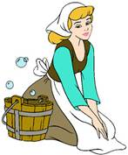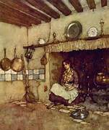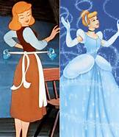
Reference:
Online Story of Grimm version of “Cinderella”
http://www.familymanagement.com/literacy/grimms/grimms16.html

Images from Bing:
http://www.bing.com/images/search?q=Raskham+illustrations+of+The+CIiderella+Story&qs=n&form=QBIR&pq=raskham+illustrations+of+the+ciiderella+story&sc=0-0&sp=-1&sk=#a
http://www.bing.com/images/search?q=disney%27s+illustrations+of+The+Cinderella+Story&FORM=HDRSC2

